Dispel that winter gloom with …..
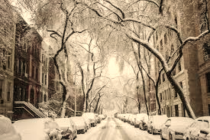

An Evening of Poetry & Song
Even when we can’t meet in person,
poetry and music can still sparkle over Zoom.
Saturday 14 November from 7.30 pm
No charge
but please support Glossopdale Foodbank with donations
And more……we are also launching a collection of verses which have sustained members of the Labour Club’s reading group through the pandemic, Lockdown Lights – free copy with every donation
Register to join on margaret.peters@live.co.uk

